**Dissecting the Digital Landscape:**

**A Comprehensive Analysis of Social Media**

**Project Report Format**

1. **INTRODUCTION**

1.1 Project Overview

1.2 Purpose

2. **IDEATION & PROPOSED SOLUTION**

2.1 Problem Statement Definition

2.2 Empathy Map Canvas

2.3 Ideation & Brainstorming

2.4 Proposed Solution

3. **REQUIREMENT ANALYSIS**

3.1 Functional requirement

3.2 Non-Functional requirements

**4. PROJECT DESIGN**

4.1 Data Flow Diagrams

4.2 Technical Architecture

4.3 User Stories

**5. CODING & SOLUTIONING**

5.1 Feature 1

5.2 Feature 2

**6. RESULTS**

6.1 Web UI

6.2Performance Metrics

**7. ADVANTAGES & DISADVANTAGES**

**8. CONCLUSION**

**9. FUTURE SCOPE**

**10. APPENDIX**

Source Code

GitHub & Project Video Demo Link

1. **INTRODUCTION**

Social media analysis refers to the process of examining and evaluating data collected from various social media platforms. With the widespread use of social media, it has become a valuable source of information for individuals, businesses, organizations, and researchers alike

.

* 1. Project Overview

The aim of this project is to conduct a comprehensive analysis of the digital landscape by examining social media data. The project will explore various aspects of social media, including user behavior, content trends, influential factors, and sentiment analysis. By analyzing data from different platforms, the project seeks to gain insights into the dynamics of social media and its impact on society.

Objectives:

1. Data Collection: Gather a diverse range of social media data from platforms such as Facebook, Twitter, Instagram, LinkedIn, YouTube, and others. Utilize APIs, web scraping techniques, or third-party tools to collect data that spans different demographics, topics, and time periods.

2. User Behavior Analysis: Analyze user behavior patterns, including posting frequency, engagement levels, and content preferences. Identify trends in user interactions, such as likes, comments, shares, and follower growth. Explore user demographics, interests, and online habits to understand the characteristics of different user segments.

3. Content Analysis: Analyze the types of content shared on social media platforms, including text, images, videos, and links. Identify popular topics, hashtags, and keywords to uncover trends and discussions. Determine the most engaging and viral content to understand the factors that contribute to content popularity and shareability.

4. Influencer Identification: Identify influential individuals or accounts within specific domains or industries. Analyze their follower base, engagement rates, and content strategies to understand the impact of influencers on social media. Evaluate the effectiveness of influencer marketing campaigns and their potential reach.

5. Sentiment Analysis: Conduct sentiment analysis on social media data to determine public sentiment towards various topics, brands, or events. Classify posts and comments as positive, negative, or neutral to gauge public opinion. Identify sentiment patterns and shifts over time to uncover insights into public sentiment dynamics.

6. Network Analysis: Explore social connections and network structures within social media platforms. Analyze the relationships between users, communities, and groups to understand the spread of information, influence, and social dynamics. Identify key opinion leaders and communities that shape discussions and trends.

7. Visualization and Reporting: Present the findings of the analysis in a visually appealing and understandable manner. Utilize charts, graphs, and interactive dashboards to convey key insights and trends. Generate comprehensive reports that summarize the analysis, methodologies, and recommendations based on the findings.

By conducting a comprehensive analysis of the social media landscape, this project aims to provide valuable insights into user behavior, content trends, influential factors, and public sentiment. The findings can be utilized by businesses, researchers, and policymakers to enhance marketing strategies, understand social dynamics, and make informed decisions in the digital era.

1.2 Purpose

The purpose of the project "Dissecting the Digital Landscape: A Comprehensive Analysis of Social Media" is to gain a deep understanding of the dynamics, trends, and impact of social media on society. The project aims to achieve the following purposes:

1. Insights into User Behavior: By analyzing user behavior on social media platforms, the project aims to uncover patterns, preferences, and habits of users. This information can help businesses tailor their marketing strategies, improve user engagement, and enhance customer satisfaction. It can also assist researchers in understanding how individuals interact, communicate, and form relationships in the digital space.

2. Identification of Trends and Influential Factors: Analyzing social media content and trends allows for the identification of popular topics, emerging discussions, and influential factors that shape public opinion. This knowledge can be valuable for businesses to stay ahead of market trends, identify potential opportunities or risks, and develop effective content strategies. Researchers can gain insights into societal interests, concerns, and shifts in public sentiment.

3. Assessment of Sentiment and Public Opinion: Conducting sentiment analysis enables the project to gauge public sentiment towards various topics, brands, or events. Understanding public opinion can be beneficial for businesses to evaluate brand reputation, assess customer satisfaction, and address potential issues. For policymakers, it can provide insights into public sentiment on policies, public initiatives, or social issues.

4. Identification of Influencers and Networks: By analyzing social media data, the project aims to identify influential individuals, communities, and networks within specific domains or industries. This information can help businesses identify potential brand ambassadors, collaborate with influential figures, and leverage influencer marketing strategies. It can also assist researchers in studying the spread of information, the impact of influential voices, and the formation of social connections.

5. Enhanced Decision-making: The project intends to provide valuable insights and recommendations based on the analysis of social media data. These insights can assist businesses in making data-driven decisions, optimizing marketing strategies, and improving brand positioning. Researchers can use the findings to generate evidence-based conclusions and contribute to academic or scientific knowledge in the field of social media analysis.

Overall, the purpose of the project is to leverage social media analysis to uncover meaningful insights, understand user behavior, identify trends, assess sentiment, and provide actionable recommendations for businesses, researchers, and policymakers operating in the digital landscape.

2. **IDEATION & PROPOSED SOLUTION**

2.1 Problem Statement Definition

Create a problem statement to understand your customer's point of view. The Customer Problem Statement template helps you focus on what matters to create experiences people will love.

A well-articulated customer problem statement allows you and your team to find the ideal solution for the challenges your customers face. Throughout the process, you’ll also be able to empathize with your customers, which helps you better understand how they perceive your product or service. 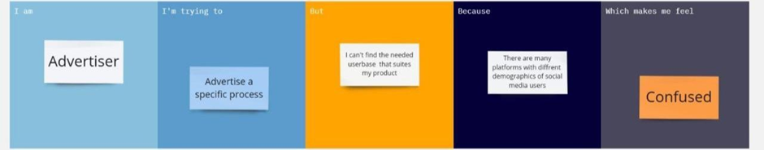

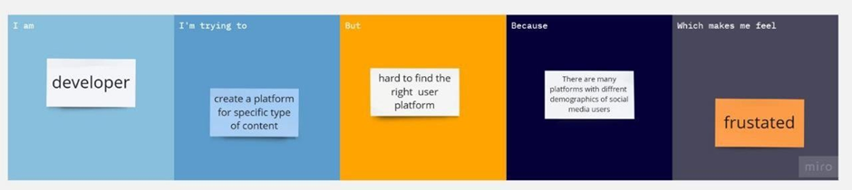

| **Problem Statement (PS)** | **I am** | **I’m trying to** | **But** | **Because** | **Which makes me feel** |
| --- | --- | --- | --- | --- | --- |
| PS-1 | Advertiser | Advertise a specific product | I can’t find the needed user base that suits my product | There are many platforms with different demographics of socialmedia | Confused |
| PS-2 | Developer | Create a platform for specific type of content | Hard to find the right user platform | Durga many platform city different demographic  of social media user | Frustrated |

2.2 Empathy Map

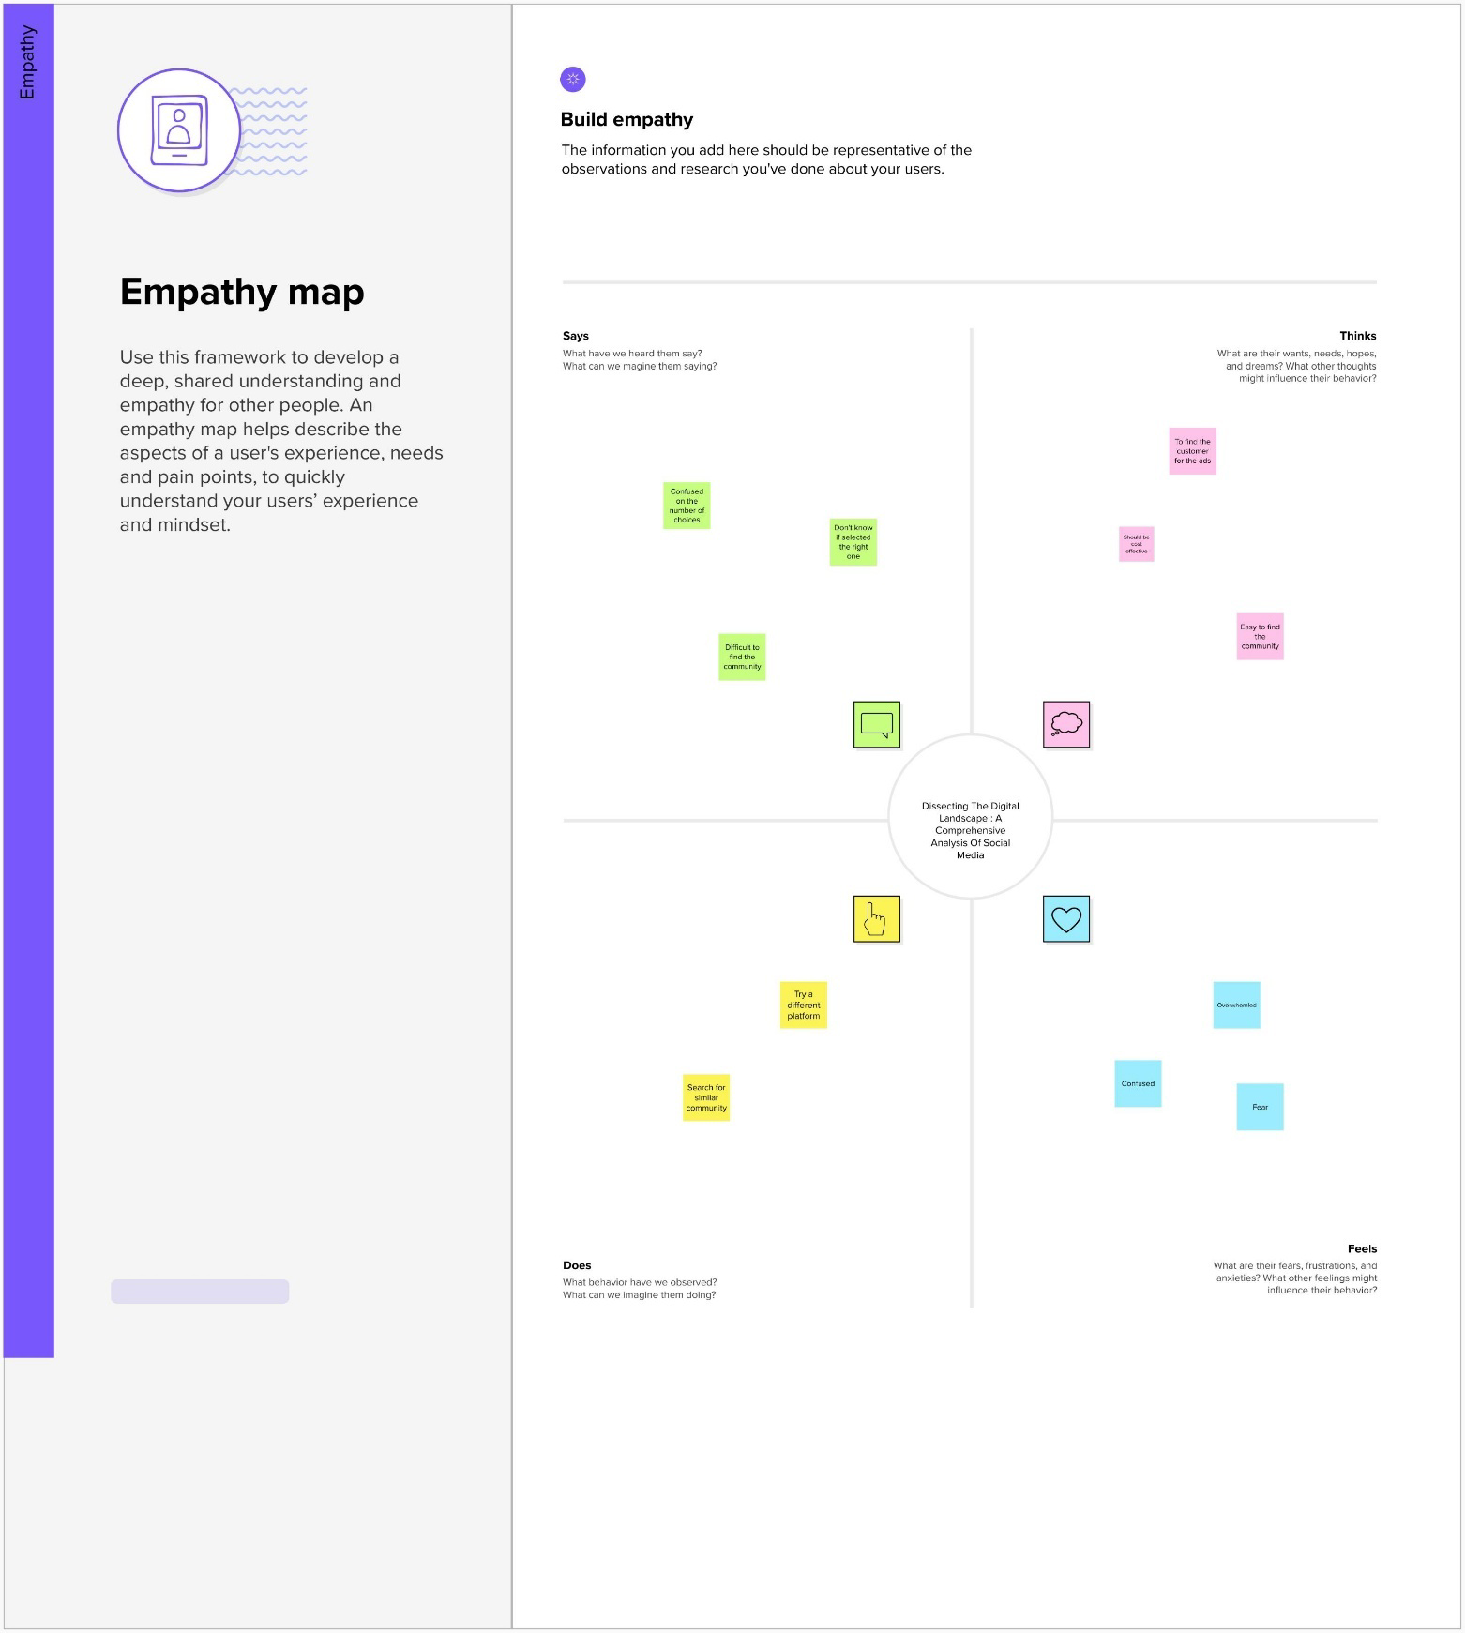

2.3 Ideation & Brainstorming

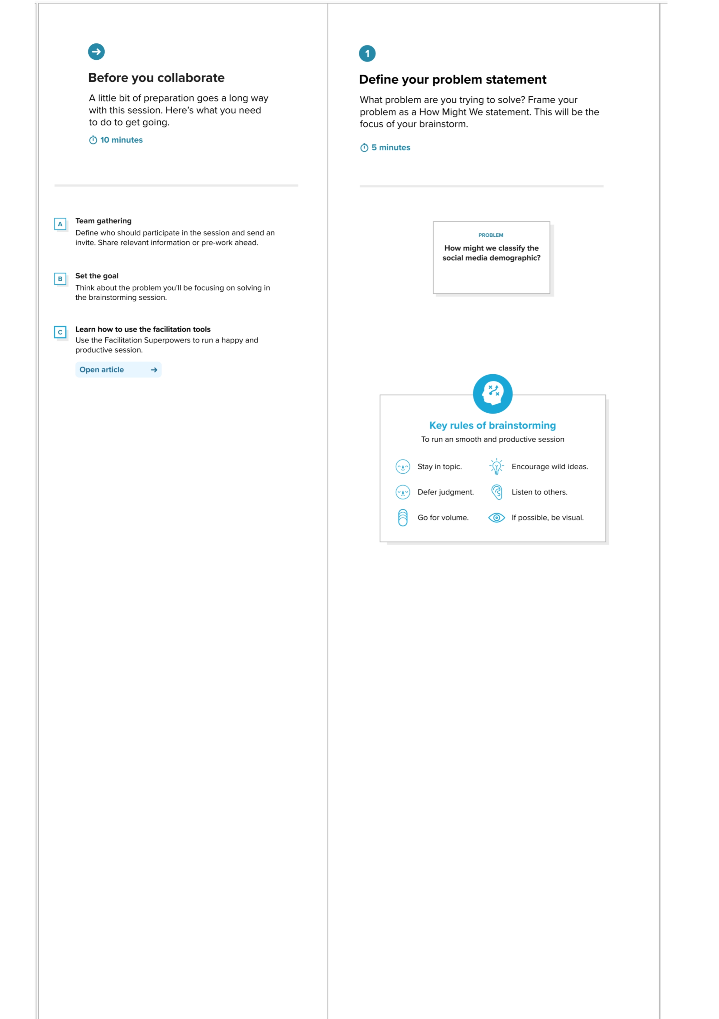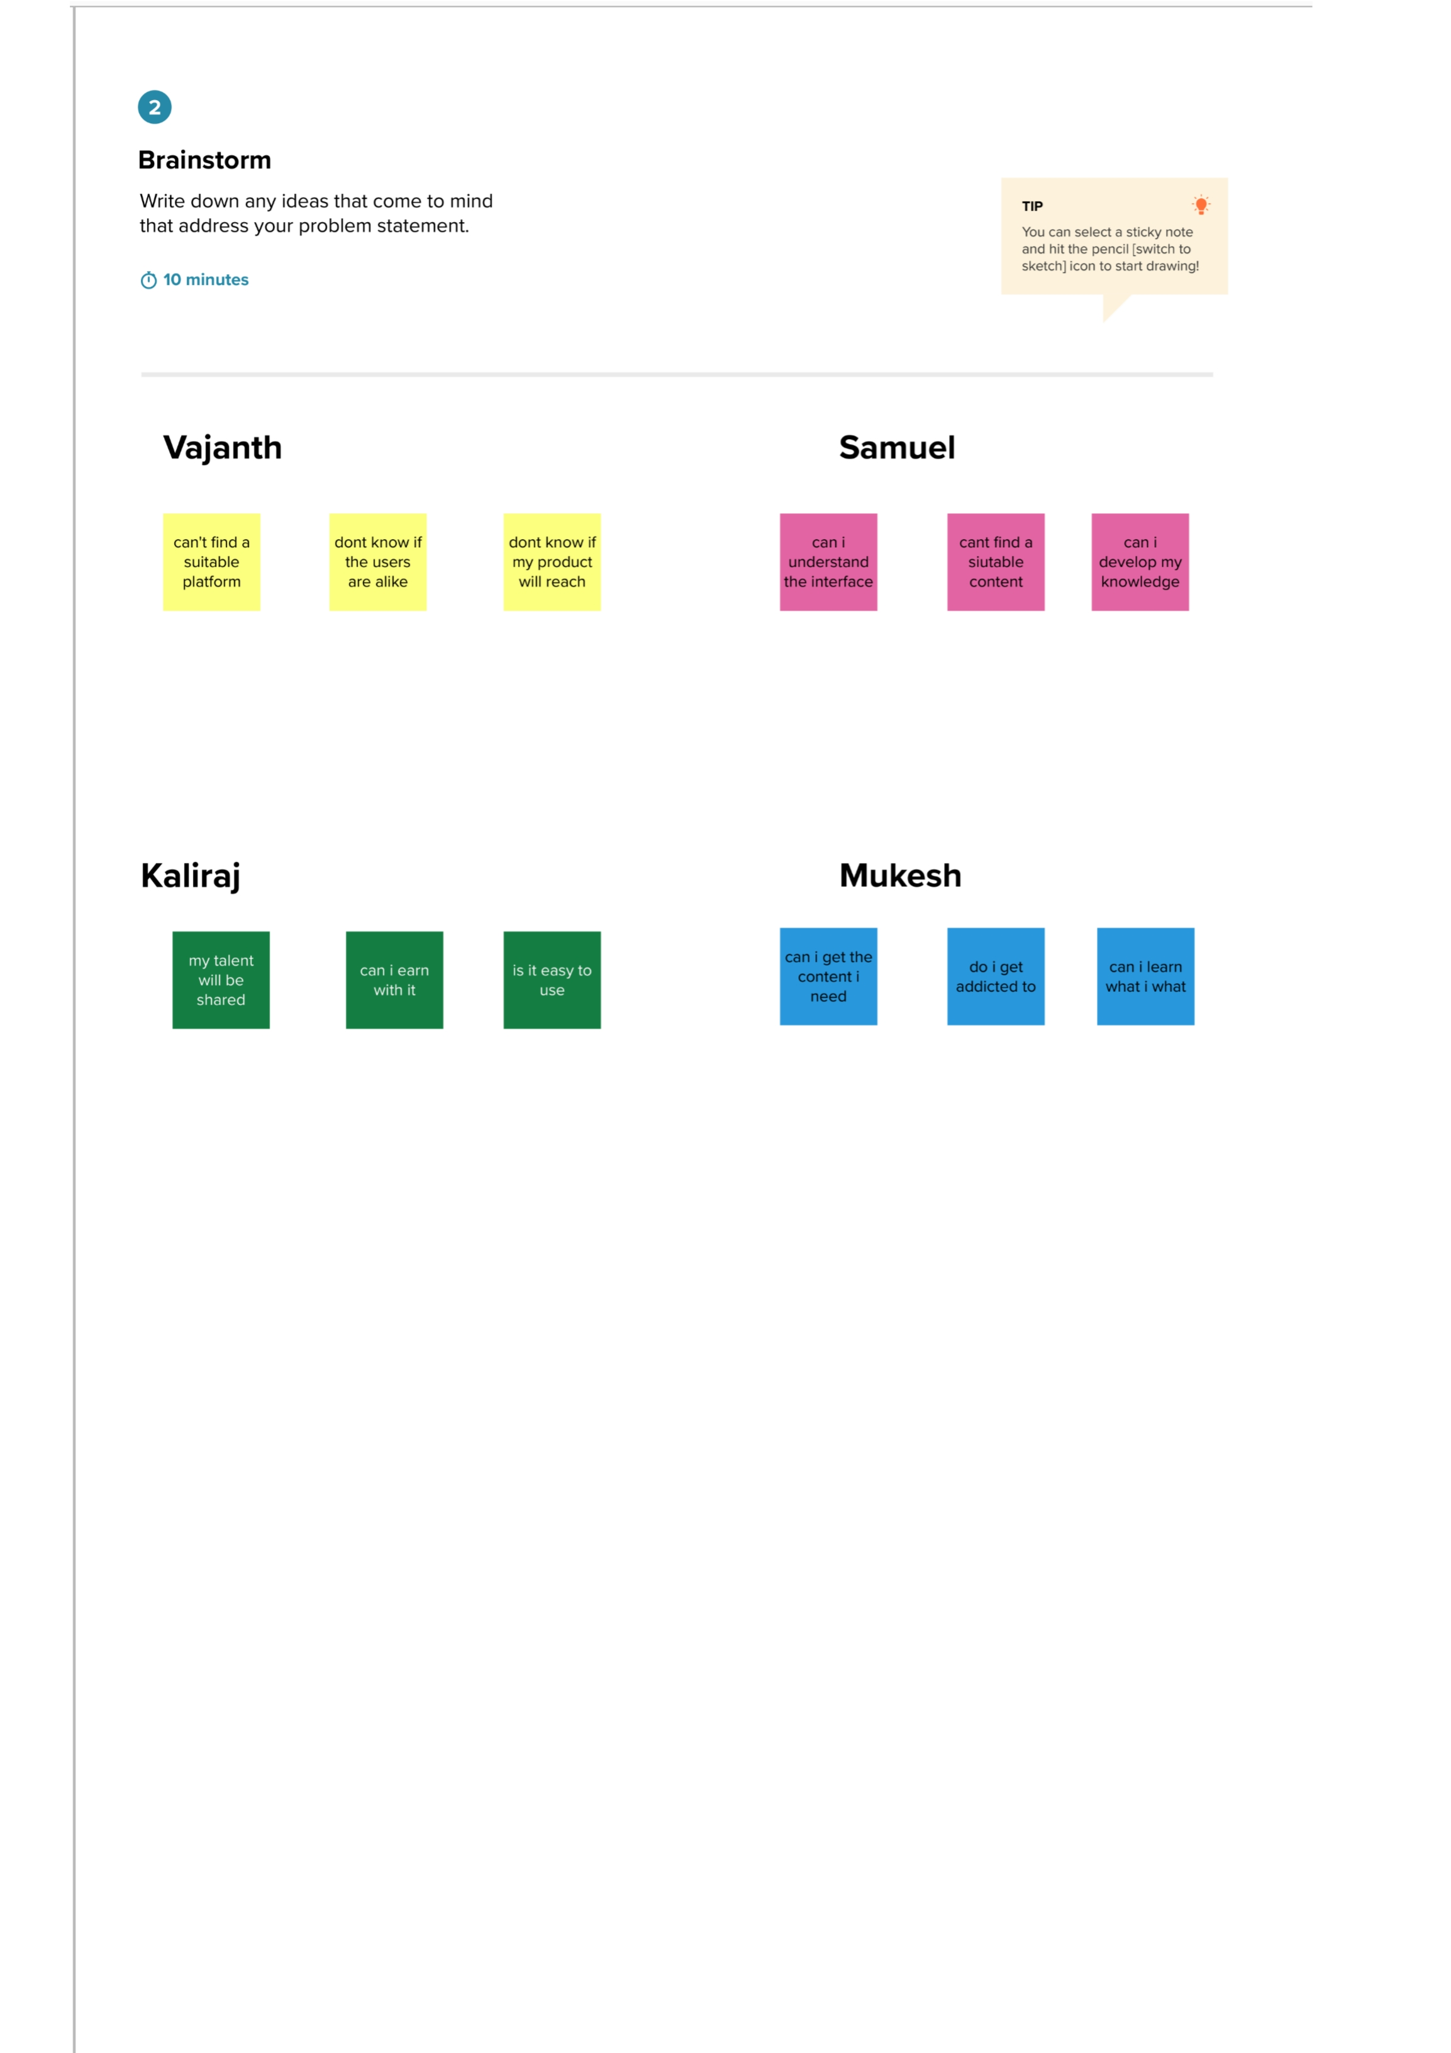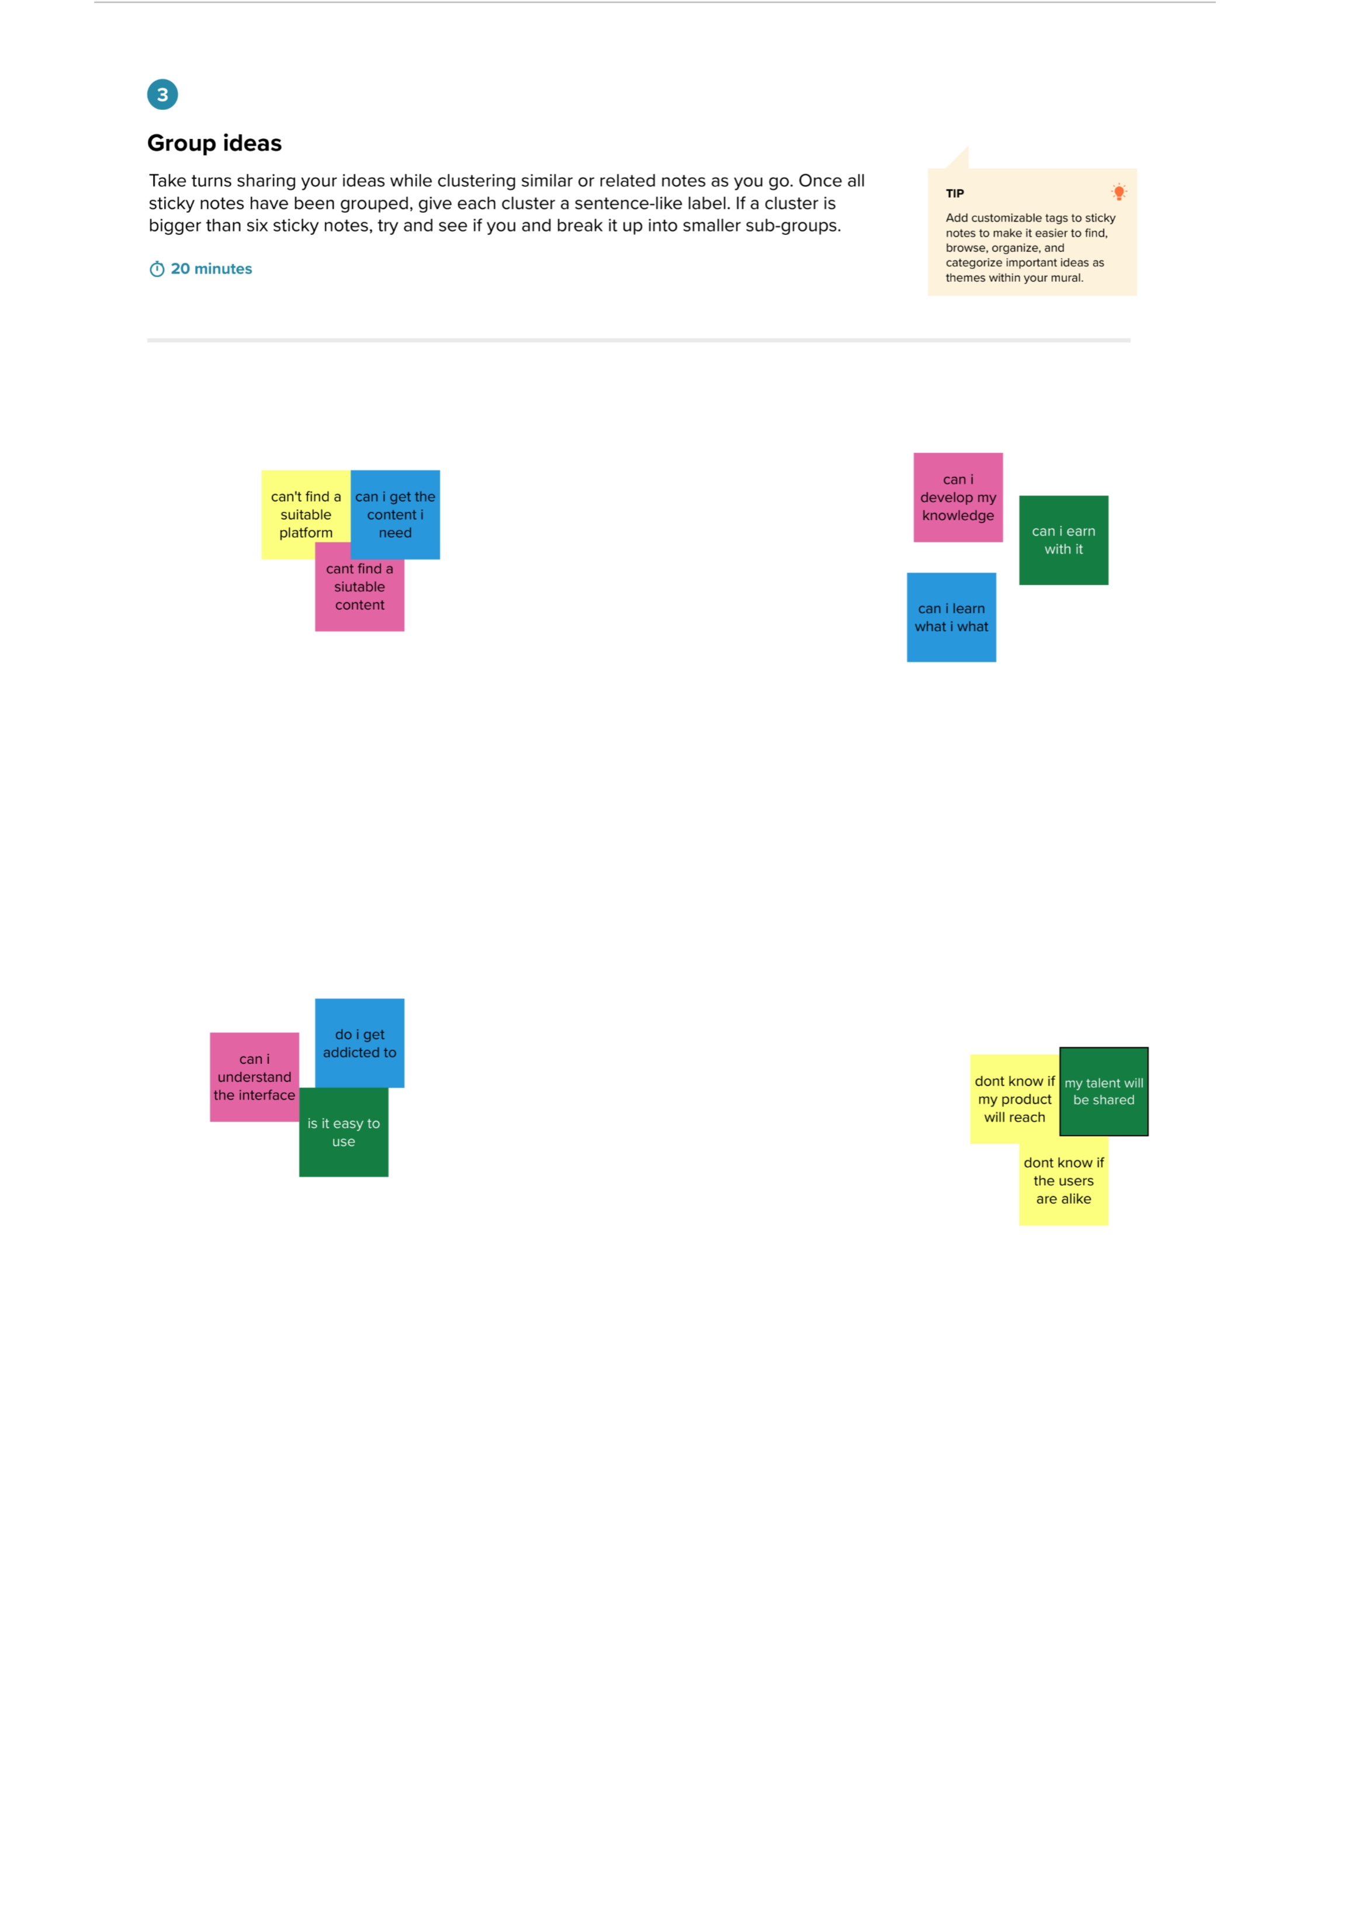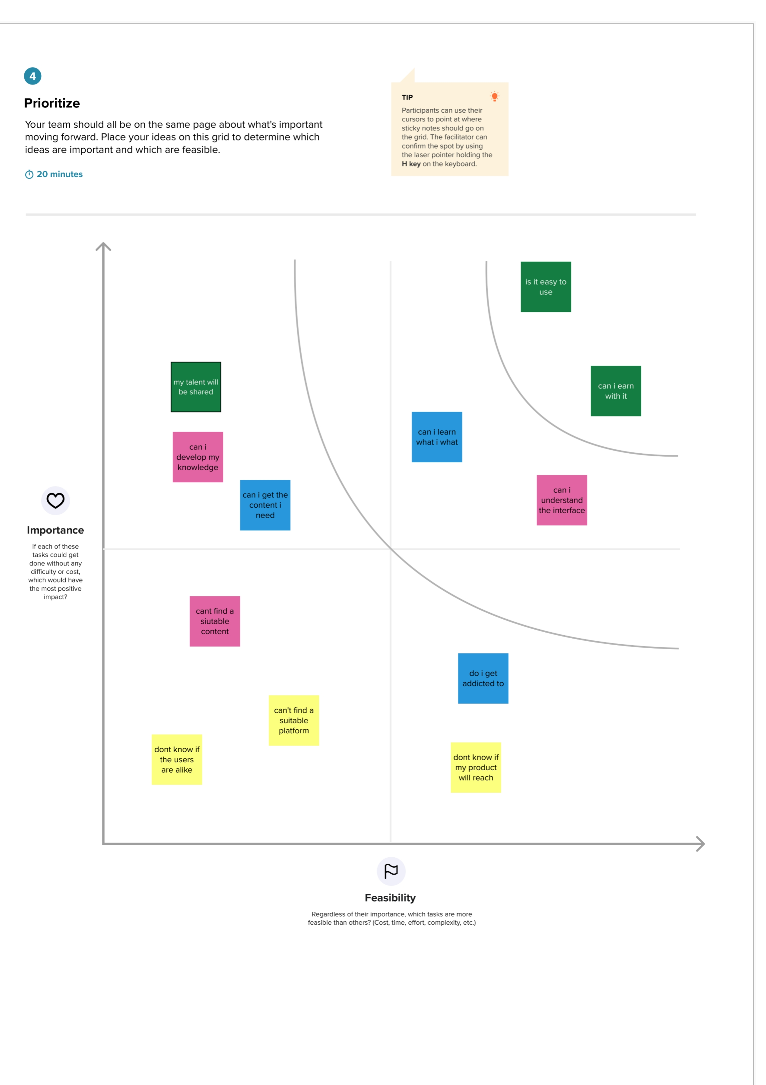

2.4 Proposed Solution

Project team shall fill the following information in proposed solution template.

| **S.No.** | **Parameter** | **Description** |
| --- | --- | --- |
|  | Problem Statement (Problem to be solved) | How can social media analytics be leveraged to improve brand reputation and customer engagement in the highly competitive online landscape? |
|  | Idea / Solution description | The solution to the problem of leveraging social media analytics to improve brand reputation and customer engagement involves a multi-faceted approach that combines data analysis, customer insights, and strategic marketing tactics.  Firstly, companies need to invest in robust social media monitoring tools that can track mentions, sentiment, and engagement metrics across various platforms. This will enable them to identify trending topics, sentiment patterns, and customer pain points, allowing for timely and effective responses.  Secondly, companies should leverage customer insights to personalize their marketing and engagement strategies. By analyzing customer data and social media interactions, businesses can better understand their audience's preferences, behavior, and needs, and tailor their messaging and offerings accordingly.  Thirdly, companies should focus on building an engaged and loyal social media community by creating engaging and shareable content, providing excellent customer service, and actively responding to customer feedback and queries.  Overall, by combining data-driven insights with personalized marketing strategies and customer engagement tactics, companies can leverage social media analytics to build stronger brand reputation and customer loyalty, ultimately driving business growth and success. |
|  | Novelty / Uniqueness | One of the novelties of the solution to leveraging social media analytics for improving brand reputation and customer engagement is the use of advanced data analysis techniques, such as sentiment analysis and topic modeling, to gain deeper insights into customer behavior and sentiment. These techniques allow companies to understand the emotional impact of their brand and messaging, as well as to identify emerging trends and issues in real-time, enabling faster and more effective responses.  Another novelty is the focus on personalized marketing and engagement strategies, which are becoming increasingly important in the digital age. By tailoring messaging and offerings to individual customer needs and preferences, companies can create a more engaging and memorable customer experience, building stronger brand loyalty and advocacy.  Finally, the emphasis on building a loyal and engaged social media community is also a novel approach. By creating a two-way dialogue with customers, responding to feedback and queries, and fostering a sense of community and shared values, companies can create a more meaningful and authentic relationship with their audience, enhancing their brand reputation and driving customer loyalty. |
|  | Social Impact / Customer Satisfaction | One of the novelties of the solution to leveraging social media analytics for improving brand reputation and customer engagement is the use of advanced data analysis techniques, such as sentiment analysis and topic modeling, to gain deeper insights into customer behavior and sentiment. These techniques allow companies to understand the emotional impact of their brand and messaging, as well as to identify emerging trends and issues in real-time, enabling faster and more effective responses.  Another novelty is the focus on personalized marketing and engagement strategies, which are becoming increasingly important in the digital age. By tailoring messaging and offerings to individual customer needs and preferences, companies can create a more engaging and memorable customer experience, building stronger brand loyalty and advocacy.  Finally, the emphasis on building a loyal and engaged social media community is also a novel approach. By creating a two-way dialogue with customers, responding to feedback and queries, and fostering a sense of community and shared values, companies can create a more meaningful and authentic relationship with their audience, enhancing their brand reputation and driving customer loyalty. |
|  | Business Model (Revenue Model) | The revenue model for leveraging social media analytics to improve brand reputation and customer engagement can take different forms, depending on the specific business goals and strategies of the company. Here are some potential revenue models:  1. Subscription-based model: Companies can charge a fee for access to their social media monitoring and analytics platform, which provides insights on customer behavior, sentiment, and engagement metrics.  2. Consultancy model: Companies can offer consulting services to help businesses analyze their social media data and develop personalized marketing and engagement strategies.  3. Advertising model: Companies can leverage their social media analytics to offer targeted advertising solutions to businesses looking to reach specific audiences on social media platforms.  4. Partnership model: Companies can form partnerships with social media platforms or other businesses to offer joint marketing and engagement solutions that leverage their social media analytics.  5. Product development model: Companies can use social media analytics to identify new product opportunities and develop products or services that meet the needs and preferences of their customers.  Overall, the revenue model for leveraging social media analytics to improve brand reputation and customer engagement can be varied and flexible, depending on the specific needs and goals of the company. |
|  | Scalability of the Solution | The scalability of the solution for leveraging social media analytics to improve brand reputation and customer engagement depends on the infrastructure, resources, and processes in place. Here are some factors that can impact the scalability of the solution:  1. Infrastructure: To scale the solution, companies need to have robust infrastructure in place, including social media monitoring tools, analytics software, and data storage and processing capabilities. This infrastructure needs to be able to handle large volumes of data and provide real-time insights to support decision-making.  2. Resources: Companies need to have skilled resources, such as data analysts, social media managers, and marketing professionals, to leverage social media analytics effectively. These resources should be trained in the latest data analysis techniques and marketing strategies and be able to work collaboratively to drive results.  3. Processes: To scale the solution, companies need to have efficient processes in place for collecting, analyzing, and acting on social media data. These processes should be streamlined, automated where possible, and optimized to drive maximum efficiency and effectiveness.  4. Integration: The solution needs to be integrated with other business processes and systems, such as customer relationship management (CRM) tools, marketing automation software, and sales systems. This integration can help to drive more personalized and effective customer interactions and provide a seamless customer experience.  Overall, the scalability of the solution for leveraging social media analytics to improve brand reputation and customer engagement depends on the level of investment in infrastructure, resources, and processes. With the right investment, companies can scale the solution to support their growth and achieve their business goals. |

**3.REQUIREMENT ANALYSIS**

# 3.1 Functional Requirements:

Following are the functional requirements of the proposed solution.

| **FR No.** | **Functional Requirement (Epic)** | **Sub Requirement (Story / Sub-Task)** |
| --- | --- | --- |
| FR-1 | Data Collection | The system should collect social media data from platforms like Twitter, Facebook, and Reddit.  It should be able to extract relevant information such as  mentions, comments, and engagement metrics. |
| FR-2 | Data Preprocessing | The system should preprocess the collected data by cleaning and normalizing it.  It should filter out duplicates, remove irrelevant information, and extract key features like hashtags and sentiment scores. |
| FR-3 | Data Analysis | The system should perform text mining, sentiment analysis, and network analysis on the preprocessed data.  It should identify trends, sentiment patterns, influencers, and key metrics related to brand reputation  and customer engagement. |
| FR-4 | Visualization and Reporting: | The system should provide visualizations and dashboards to present the analyzed data.  It should generate reports summarizing key insights, trends, and performance metrics for stakeholders. |
| FR-5 | Engagement and Monitoring: | The system should enable real-time monitoring of social media platforms for brand mentions, customer feedback, and complaints.  It should provide notifications/alerts for negative mentions or important events that require immediate attention.  It should allow users to engage with customers,  respond to inquiries, and manage customer interactions within the platform. |

# 3.2Non-functional Requirements:

Following are the non-functional requirements of the proposed solution.

| **FR No.** | **Non-Functional Requirement** | **Description** |
| --- | --- | --- |
| NFR-1 | **Usability** | The system should have an intuitive and user- friendly interface for users to navigate, configure settings, and interpret the results.  It should provide easy-to-use filters, search  functionality, and customizable reports. |
| NFR-2 | **Security** | The system should ensure data privacy and comply with applicable data protection regulations.  It should have appropriate access controls and encryption mechanisms to safeguard sensitive information. |
| NFR-3 | **Reliability** | The system should support integration with social media platforms' APIs for data collection.  It should have the ability to integrate with other  systems like CRM, marketing automation tools, or analytics platforms. |
| NFR-4 | **Performance** | The system should handle large volumes of social media data efficiently.  It should provide real-time or near real-time analysis and notifications.  It should have minimal latency in collecting,  processing, and analyzing data. |
| NFR-5 | **Scalability** | The system should be scalable to handle increasing data volumes and growing user demands.  It should support the addition of new social media platforms or data sources as needed. |

**4. PROJECT DESIGN**

4.1 Data Flow Diagrams

A Data Flow Diagram (DFD) is a traditional visual representation of the information flows within a system. A neat and clear DFD can depict the right amount of the system requirement graphically. It shows how data enters and leaves the system, what changes the information, and where data is stored.

  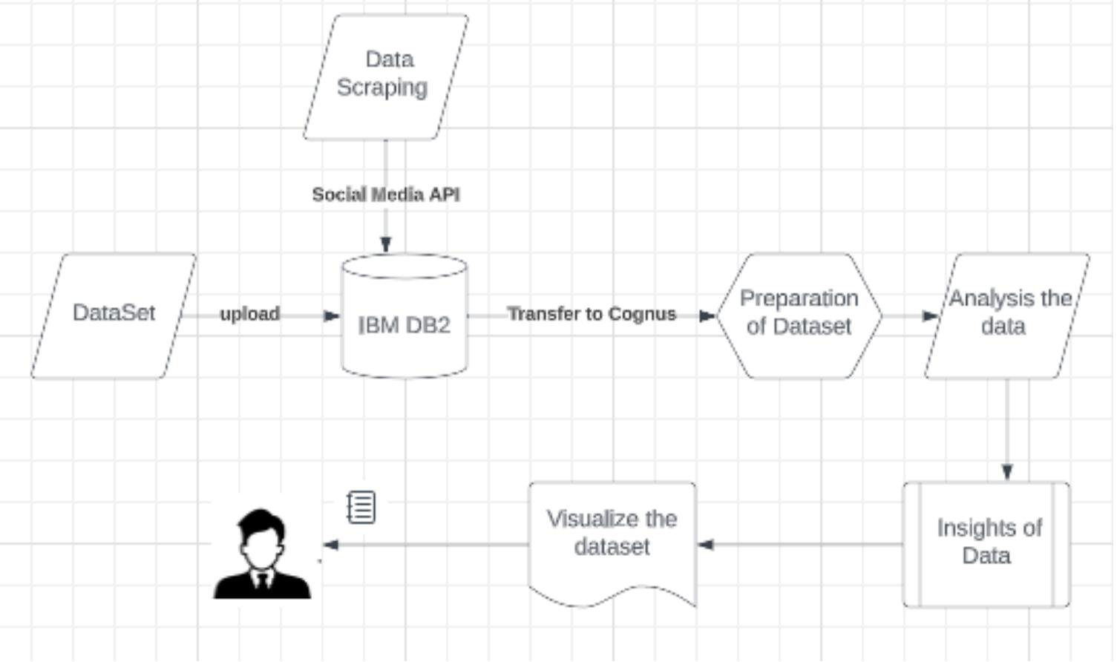

4.2 Technical Architecture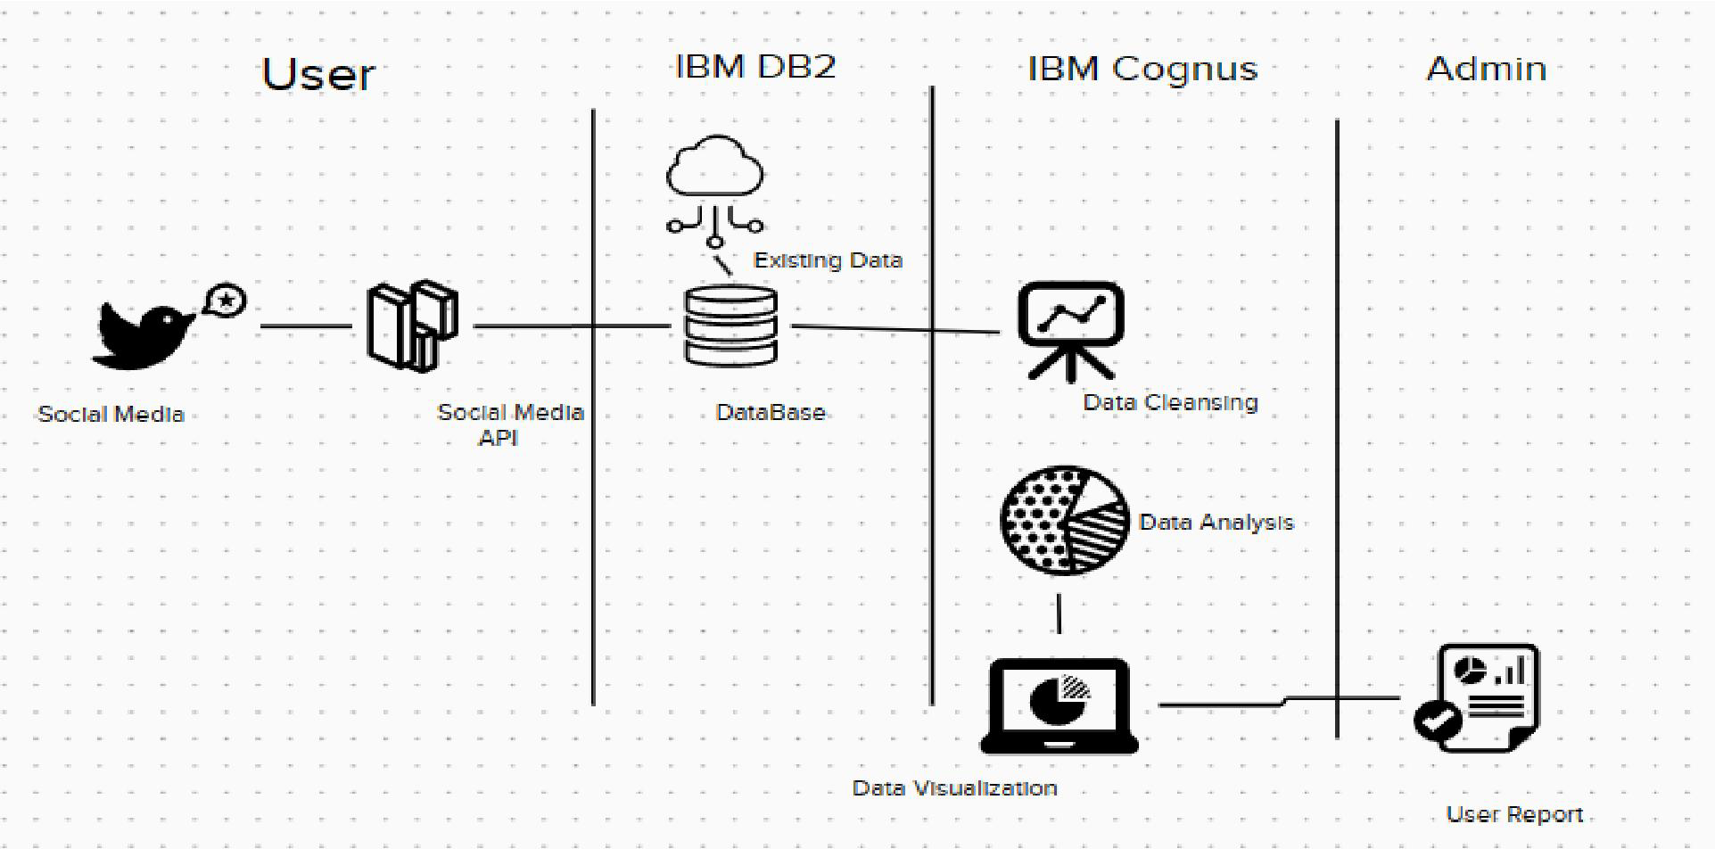

**Table-1 : Components & Technologies:**

| **S.No** | **Component** | **Description** | **Technology** |
| --- | --- | --- | --- |
|  | User Interface | Dashboard And Story Embed With UI With Flask |  |
|  | Application Logic-1 | * Pandas is a powerful Python library for data analysis. It provides a variety of tools for cleaning data, including functions for identifying and removing duplicate data, identifying and correcting missing data, and identifying and correcting errors. | Python |
|  | Application Logic-2 | * NumPy is a Python library for scientific computing. It provides a variety of functions for working with arrays, including functions for cleaning data, such as the np.unique() function for identifying unique values and the np.isnan() function for identifying missing values. | IBM Watson STT service |
|  | Database | Csv and xml files | MySQL |
|  | Cloud Database | Database Service on Cloud | IBM DB2 |
|  | External API-1 | Web scraping the dataset form twitter | Twitter Streaming API. |
|  | External API-2 | Web scraping the dataset form facebook | Facebook Real-time Updates API |
|  | Infrastructure (Server / Cloud) | Application Deployment on  Cloud Server Configuration : | IBM dataserver |

**Table-2: Application Characteristics:**

| **S.No** | **Characteristics** | **Description** | **Technology** |
| --- | --- | --- | --- |
|  | Open-Source Frameworks | Dash is a Python framework for building web applications with interactive visualizations.  It can be used for creating custom dashboards and data visualization interfaces to present social media analytics results to users. | Dash by Plotly |
|  | Security Implementations | 1. Access Control:     - Implement user authentication mechanisms, such as username/password or multi-factor authentication, to control access to the system.     - Enforce role-based access control (RBAC) to grant appropriate privileges to users based on their roles and responsibilities.     - Set up access control lists (ACLs) to restrict access to specific data or functionalities.  2. Encryption:     - Encrypt sensitive data at rest and in transit to protect it from unauthorized access or interception.     - Use secure protocols, such as HTTPS, for communication between components of the system.     - Employ strong encryption algorithms and ensure proper key management practices.  3. Data Masking and Anonymization:     - Apply data masking techniques to replace sensitive information with fictional or obfuscated data in non-production environments.     - Anonymize personally identifiable information (PII) or other sensitive data before performing analysis or sharing with third parties.  4. Secure Coding Practices:     - Adhere to secure coding practices to prevent common vulnerabilities, such as SQL injection, cross-site scripting (XSS), or code injection attacks.     - Regularly update and patch software dependencies to address any known security vulnerabilities.     - Conduct regular code reviews and security testing to identify and address potential security flaws.  5. Logging and Monitoring:     - Implement comprehensive logging mechanisms to capture system activities, user actions, and security-related events.     - Set up a centralized log management system and establish monitoring processes to detect and respond to security incidents in a timely manner.     - Use intrusion detection and prevention systems (IDS/IPS) to monitor network traffic and detect potential threats.  6. Data Privacy Compliance:     - Comply with applicable data protection regulations, such as GDPR (General Data Protection Regulation) or CCPA (California Consumer Privacy Act).     - Obtain explicit user consent for collecting and processing their personal data.     - Implement mechanisms to honor user preferences for data sharing, opt-outs, and data deletion requests. | RBAC,ACL,HTTPS |
|  | Scalable Architecture | Horizontal Scaling:  Design the system to support horizontal scaling, which involves adding more instances or nodes to distribute the workload.  Use load balancers to evenly distribute incoming requests across multiple instances, ensuring efficient utilization of resources.  Distributed Data Storage:  Utilize distributed data storage systems, such as NoSQL databases or data lakes, that can scale horizontally by adding more nodes to accommodate growing data volumes.  Consider sharding or partitioning strategies to distribute data across multiple nodes, enabling parallel processing and efficient data retrieval.  Distributed Processing:  Leverage distributed processing frameworks, like Apache Spark or Hadoop, to distribute computational tasks across a cluster of machines.  Break down data processing tasks into smaller units that can be executed in parallel across multiple nodes, enabling efficient processing of large datasets.  Asynchronous Communication:  Employ asynchronous communication patterns, such as message queues or event-driven architectures, to decouple components and enable scalability.  Use message brokers, like Apache Kafka or RabbitMQ, to handle event-based communication between components and ensure efficient processing and scalability.  Caching:  Implement caching mechanisms to store frequently accessed data and reduce the load on backend systems.  Utilize in-memory caches or distributed caching systems to improve response times and handle high volumes of read-intensive operations.  Auto-Scaling:  Implement auto-scaling mechanisms that can dynamically adjust the number of resources based on workload demands.  Utilize cloud infrastructure services or container orchestration platforms that provide auto-scaling capabilities, ensuring resources are provisioned and de-provisioned automatically.  Elasticity:  Design the architecture to be elastic, allowing it to scale both up and down based on demand.  Ensure that resources can be provisioned and de-provisioned quickly and efficiently to match the workload fluctuations.  Performance Optimization:  Continuously monitor and optimize the performance of the system to identify and address bottlenecks.  Use performance testing and profiling tools to identify areas for improvement and optimize resource utilization.  Cloud Infrastructure:  Leverage cloud infrastructure services that offer scalability features and on-demand resource provisioning.  Cloud platforms provide the flexibility to scale resources as needed, allowing you to handle sudden spikes in traffic or data volumes.  Load Testing:  Conduct regular load testing to simulate high-volume scenarios and validate the system's scalability.  Identify the system's capacity limits and ensure it can handle anticipated growth and peak loads. | Caching, Distributed Computing, Horizontal Scaling, Cloud Infrastructure etc,. |
|  | Availability | 1. Redundancy and Fault Tolerance:     - Implement redundancy at various levels, such as hardware, software, and network infrastructure, to minimize single points of failure.     - Use load balancers, redundant servers, and network devices to distribute traffic and ensure continuous service availability.     - Employ fault-tolerant mechanisms like clustering, replication, or data mirroring to provide backup and failover capabilities.  2. Disaster Recovery:     - Have a comprehensive disaster recovery plan in place to handle catastrophic events that could impact the availability of the project.     - Regularly back up data and store backups in secure off-site locations.     - Test the recovery procedures to ensure that data and services can be restored quickly in the event of a disaster.  3. Monitoring and Alerting:     - Set up robust monitoring systems to track the health and performance of the project's components.     - Monitor server metrics, network connectivity, database performance, and other critical parameters.     - Implement automated alerting mechanisms to notify administrators of any anomalies, performance degradation, or service disruptions.  4. Scalable Infrastructure:     - Utilize scalable cloud infrastructure that can dynamically adjust resources based on demand.     - Leverage auto-scaling capabilities to automatically scale up or down the infrastructure as needed.     - Design the architecture to accommodate increased traffic and user loads without affecting the system's availability.  5. Regular Maintenance and Updates:     - Perform regular maintenance tasks, such as applying software patches, security updates, and system upgrades.     - Schedule maintenance windows during periods of low user activity to minimize disruptions.     - Perform thorough testing after updates or changes to ensure that the system remains available and functional.  6. Proactive Monitoring and Incident Response:     - Implement proactive monitoring of the project to detect and address potential issues before they impact availability.     - Establish an incident response process to handle service disruptions or downtime promptly.     - Have a dedicated team in place to respond to incidents, investigate the root causes, and implement necessary remediation measures.  7. Service Level Agreements (SLAs):     - Define and adhere to service level agreements that specify the expected availability of the project.     - Establish clear uptime targets and response times for addressing incidents or service disruptions.     - Regularly measure and report on the project's availability against the agreed-upon SLAs. | Redundancy and Fault Tolerance, Disaster Recovery, . Monitoring and Alerting, Proactive Monitoring and Incident Response, . Service Level Agreements (SLAs) |
|  | Performance | 1. Efficient Data Storage and Retrieval:     - Choose an appropriate data storage solution, such as a NoSQL database or data lake, that can handle large volumes of data efficiently.     - Optimize data schema and indexing to ensure fast and efficient data retrieval for various types of queries.     - Utilize caching mechanisms to store frequently accessed data in memory and reduce the load on the backend systems.  2. Data Processing and Analytics:     - Utilize distributed processing frameworks like Apache Spark or Hadoop to parallelize data processing tasks and handle large datasets effectively.     - Optimize data processing algorithms and queries to minimize execution time and resource consumption.     - Implement batch processing or real-time stream processing based on the specific requirements of the analytics tasks.  3. Performance-Oriented APIs:     - Design efficient and optimized APIs to handle client requests and data retrieval.     - Minimize unnecessary data transfer and payload size by utilizing pagination, filtering, and compression techniques.     - Employ caching mechanisms at the API level to cache frequently requested data and reduce backend processing.  4. Asynchronous Processing:     - Utilize asynchronous processing patterns, such as message queues or event-driven architectures, to decouple components and improve overall performance.     - Offload time-consuming tasks to background processes or worker queues, allowing the application to respond quickly to user interactions.  5. Optimized Front-End:     - Optimize front-end code, such as HTML, CSS, and JavaScript, to ensure fast loading and rendering of the user interface.     - Minimize the number of HTTP requests, leverage browser caching, and employ techniques like lazy loading and code minification.     - Implement responsive design to ensure the application performs well on different devices and screen sizes.  6. Caching and Content Delivery Networks (CDNs):     - Use caching mechanisms to store static or infrequently changing content, reducing the load on the backend servers.     - Employ Content Delivery Networks (CDNs) to distribute content geographically and deliver it from servers closer to the user's location, improving response times.  7. Performance Testing and Optimization:     - Conduct thorough performance testing to identify bottlenecks, measure response times, and identify areas for improvement.     - Use profiling tools and performance monitoring to analyze system behavior, identify performance hotspots, and optimize resource utilization.     - Continuously monitor and optimize the performance of the application based on real-world usage patterns and feedback from users.  8. Scalable Infrastructure:     - Deploy the application on scalable infrastructure, such as cloud platforms, to handle increased traffic and user demands.     - Utilize auto-scaling capabilities to automatically adjust resources based on the workload.     - Employ load balancing to distribute traffic evenly across multiple instances and ensure efficient resource utilization.  9. Efficient Database Queries:     - Optimize database queries by analyzing query execution plans, indexing strategies, and query optimization techniques.     - Utilize database caching mechanisms, query result caching, or in-memory databases to improve query performance.  10. Network and Latency Optimization:      - Minimize network latency by reducing the number of round trips required for data retrieval and implementing efficient network protocols.      - Employ techniques like connection pooling, compression, and parallel processing to optimize network communication. | NoSQL databases, Apache Spark, Redis or Memcached, cloud infrasture  of ibm cloud, Performance testing and profiling tools |

4.3 Stories

| **User Type** | **Functional**  **Requirement (Epic)** | **User Story / Task** | **Acceptance criteria** | **Priority** | **Team Member** |
| --- | --- | --- | --- | --- | --- |
| marketing manager | Brand Image | As a marketing manager, I want to be able to track mentions of my brand on social media, so that I can monitor customer sentiment and respond to customer inquiries in a timely manner. | The system should collect real-time mentions of the brand from major social media platforms.  The system should classify each mention as positive, negative, or neutral sentiment.  The system should provide a dashboard displaying the total number of mentions and sentiment distribution. The system should send real- time notifications when a negative mention is detected. The system should provide the ability to respond directly to mentions within the  platform. | High | Kali |
| social media analyst | Classify Users | Identify users who have a high number of followers and frequently talk about the brand.  Develop a model to classify users as influencers, advocates, or detractors based on their engagement with the brand.  Provide a list of influencers and advocates to the marketing team to develop targeted marketing campaigns. | The system should identify social media users with a high number of followers or engagement rates.  The system should rank influencers based on their relevance and influence within the brand's industry.  The system should provide demographic information and engagement metrics for each Identified influencer.  The system should allow the export of influencer data for further analysis and engagement stratergies | High | Samuel |
| Product  manager | Develop  project | As a product manager,I want to be able to  track user feedback  and sentiment on  social media, so that I can identify areas for improvement and  develop new product  features that address  customer needs and  preferences | The system should collect user feedback from social media platforms, including comments, reviews, and direct messages. The system should analyze sentiment to identify positive, negative, and neutral feedback. The system  should categorize feedback based on product features, usability, and overall satisfaction.  The system should provide trend analysis of feedback over time to identify emerging patterns.  The system should allow product managers to generate reports summarizing key feedback themes and prioritize feature development based on user needs. | High | Vajanth |
| Business  Owner | Investment | As a business owner, I  want to be able to  measure the effectiveness of my social media campaigns, so that I can optimize my marketing budget and maximize return on investment. | The system  Should track ke performance indicators (KPIs) such as reach, engagement, click-through rates, and conversions for each social media campaign.  The system should provide visualizations and reports comparing the performance of different campaigns.  The system should allow the integration of cost data to calculate ROI for each campaign. The system should provide insights on the best-performing channels and content types for  future campaign optimization. | Medium | Vajanth |

**6. RESULTS**

6.1 Web UI

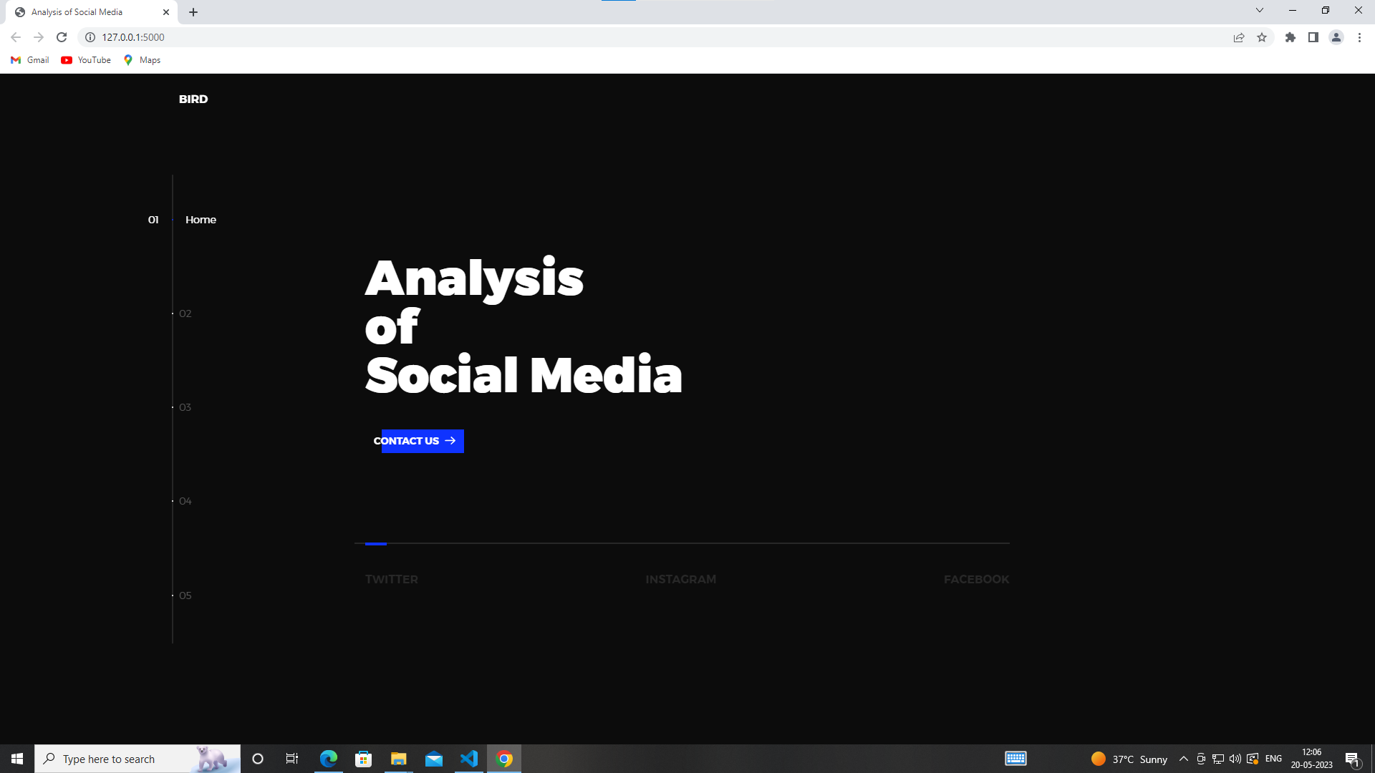

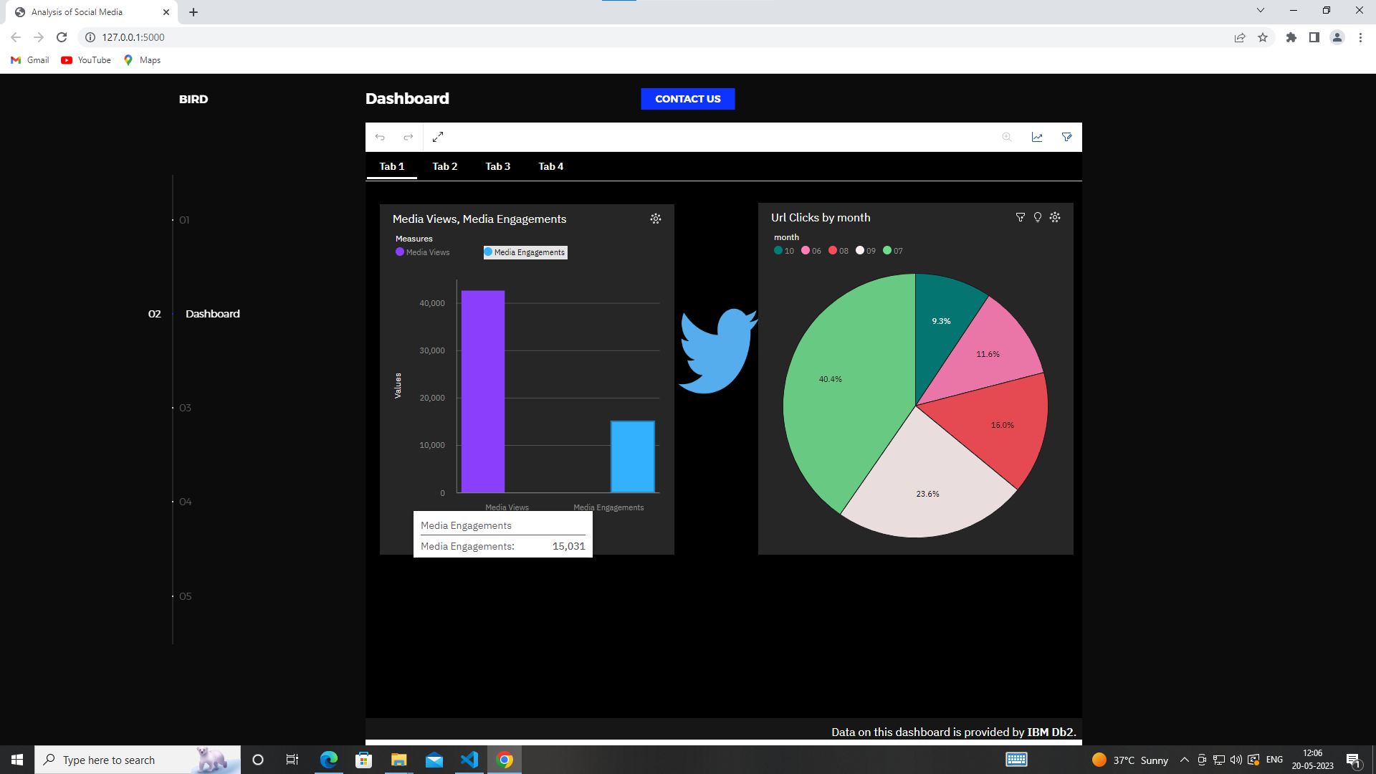

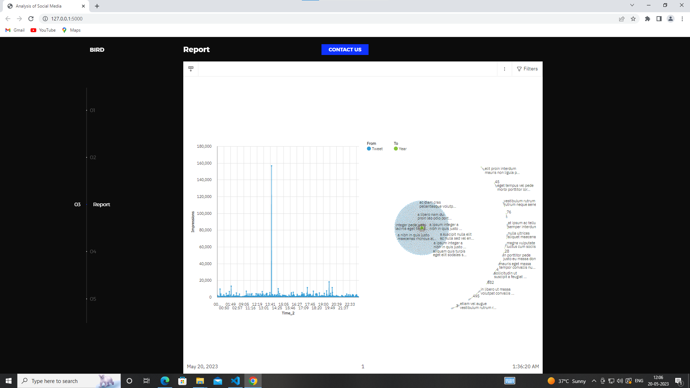

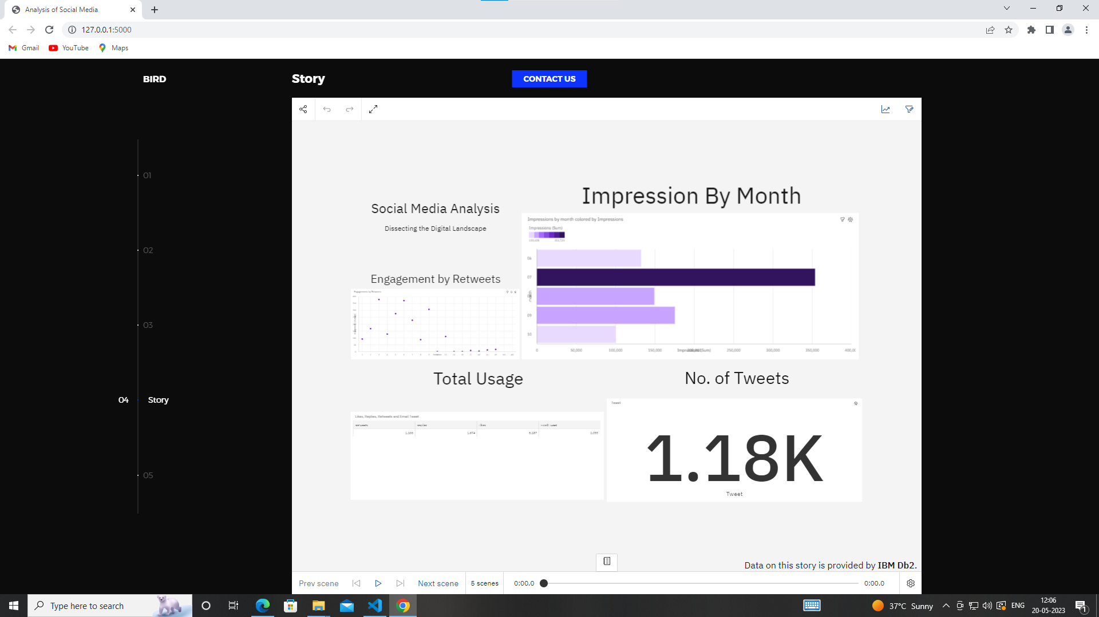

6.2 Performance Metrics

Project team shall fill the following information in the performance testing template.

| **S.No.** | **Parameter** | **Screenshot / Values** |
| --- | --- | --- |
| 1. | Dashboard design | No of Visualizations / Graphs -  1.No.of URL clicks by month  2.Data of media view, media engagements  3.No.of impressions by month  4.Impressions by retweets  5.Engagements by retweet in year  6.detailed expands through hashtag clicks  7.Table of email tweets, retweets and likes  8.No.of retweets, tweets, likes, App opens |
| 2. | No. of Calculation fields |  |
| 3. | Utilization of Data Filters | Filters are used to exclude the unwanted data present int the dataset which cant be deleted entirely |

**7. ADVANTAGES & DISADVANTAGES**

**Advantages**

* + Data Integration: IBM Cognos Social Media Analysis allows you to gather and integrate data from various social media platforms, providing a comprehensive view of social media interactions and trends. This enables you to analyze and understand customer sentiment, preferences, and behavior.
  + Real-time Insights: The embedded IBM Cognos Social Media Analysis code in your website can provide real-time insights into social media conversations and activities. This allows you to stay up-to-date with the latest trends, mentions, and sentiments related to your brand, products, or industry.
  + Enhanced Decision-making: By analyzing social media data through IBM Cognos, you can make more informed decisions. The insights gained from social media analysis can help you identify opportunities, address customer concerns, improve marketing strategies, and enhance overall business performance.
  + Competitive Advantage: Social media analysis with IBM Cognos can give you a competitive edge by providing valuable insights into your competitors’ activities and customer perceptions. This information can be used to refine your marketing campaigns, differentiate your offerings, and stay ahead of the competition.
  + Customer Engagement: By understanding social media conversations, you can engage with your customers more effectively. IBM Cognos Social Media Analysis allows you to identify customer preferences, respond to queries or complaints promptly, and improve customer satisfaction and loyalty.

**Disadvantages**

* + Data Privacy and Security: Social media analysis involves handling and analyzing a vast amount of data, including potentially sensitive customer information. It is crucial to ensure proper data privacy and security measures are in place to protect customer data from unauthorized access or breaches.
  + Accuracy and Reliability: Social media data can be noisy and prone to inaccuracies. It is essential to apply appropriate data cleansing, filtering, and validation techniques to ensure the accuracy and reliability of the insights generated through IBM Cognos Social Media Analysis.
  + Complexity and Skill Requirements: Implementing and effectively utilizing IBM Cognos Social Media Analysis may require technical expertise and resources. It may involve configuring data connectors, setting up analytics models, and interpreting the results. Adequate training or expertise in social media analysis is necessary for optimal utilization of the tool.
  + Limited Context: Social media analysis primarily focuses on online interactions and may provide limited context compared to other research methods. It is important to consider social media data in conjunction with other data sources and traditional market research methods for a comprehensive understanding of customer behavior.
  + Constantly Evolving Social Media Landscape: Social media platforms and their algorithms are continuously evolving. This can pose challenges in keeping up with changes and ensuring the effectiveness of social media analysis techniques. Regular updates and adaptations may be required to stay current and derive meaningful insights.
  + It is important to weigh these advantages and disadvantages in the context of your specific business needs, resources, and objectives when considering the integration of IBM Cognos Social Media Analysis with embed code in a website.

**8.Conclusion**

In conclusion, integrating IBM Cognos Social Media Analysis with embed code in a website offers several advantages for businesses seeking to harness the power of social media data. It enables data integration, real-time insights, enhanced decision-making, competitive advantage, and improved customer engagement. However, there are also considerations to keep in mind, such as data privacy and security, accuracy and reliability of social media data, technical complexity, limited context, and the evolving nature of social media platforms.

It is crucial for organizations to carefully evaluate their specific requirements, resources, and goals before implementing IBM Cognos Social Media Analysis. This evaluation will help determine whether the benefits outweigh the challenges and whether the tool aligns with the organization’s overall social media and business intelligence strategies. By leveraging the strengths of IBM Cognos Social Media Analysis and mitigating the potential drawbacks, businesses can gain valuable insights from social media data and make informed decisions to drive success in today’s digitally connected world.

**9.Future Scope**

The future scope of IBM Cognos Social Media Analysis and similar tools is promising as the field of social media analytics continues to evolve. Here are some potential areas of future development and expansion:

1. Advanced Sentiment Analysis: Enhancements in natural language processing and machine learning techniques can lead to more advanced sentiment analysis capabilities. This can enable more accurate and nuanced understanding of customer sentiment, emotions, and opinions expressed on social media platforms.

2. Social Media Influencer Analysis: Identifying and engaging with social media influencers can be crucial for marketing and brand promotion. Future advancements may involve incorporating influencer analysis capabilities into social media analytics tools, allowing businesses to identify, track, and collaborate with relevant influencers more effectively.

3. Social Listening and Trend Prediction: Improved social listening capabilities can enable businesses to proactively identify emerging trends, customer needs, and market shifts. Predictive analytics algorithms can help forecast future trends and customer behavior based on historical social media data, aiding in strategic decision-making.

4. Cross-Channel Integration: Integrating social media analytics with other channels, such as customer relationship management (CRM) systems and sales data, can provide a holistic view of customer interactions and journeys. This integration can offer deeper insights into the impact of social media on customer acquisition, retention, and overall business performance.

5. Real-time Monitoring and Alerting: The ability to monitor social media activities in real-time and receive timely alerts for specific events, mentions, or trends can be invaluable for businesses. Future developments may focus on enhancing real-time monitoring capabilities and providing proactive notifications to facilitate immediate action.

6. Visualization and Interactive Reporting: Advancements in data visualization and interactive reporting can enhance the user experience and make complex social media analytics more accessible to non-technical users. Interactive dashboards, customizable visualizations, and self-service reporting features can empower users to explore data and gain insights intuitively.

7. Integration with AI and Automation: Integration of social media analytics with artificial intelligence (AI) technologies can automate repetitive tasks, such as data collection, sentiment analysis, and response generation. This integration can save time and resources while enabling more efficient and personalized engagement with customers.

8. Ethical and Privacy Considerations: As the importance of data ethics and privacy increases, the future scope of social media analytics will involve addressing ethical and privacy concerns associated with handling user-generated content. Stricter regulations and best practices will shape the development and implementation of social media analytics tools.

Overall, the future of IBM Cognos Social Media Analysis and similar tools lies in leveraging advanced analytics, integrating multiple data sources, and embracing emerging technologies to provide deeper insights, improved user experiences, and more effective decision-making for businesses in the dynamic world of social media

**10. APPENDIX**

Dataset Used : <https://drive.google.com/file/d/1-cpLzyRyW_z6Z78dRUhBIBm-Xoybt-Y4/view?usp=drivesdk>

Video Recordings : <https://drive.google.com/drive/folders/1bu-NmOpgaQaoaOQnYd97Zm1IV0yeMk78>

Web UI Files : <https://drive.google.com/drive/folders/1qWHNJX7S3drdlkUloHfLhW0x9ed0tEDx>

Github Repository : <https://github.com/naanmudhalvan-SI/PBL-NT-GP--4502-1680767444>